SIMATS ENGINEERING
CO4-ASSESSMENT TOOL3- INTEGRATED EXPERIMENTS

COURSE NAME: Artificial Intelligence COURSE CODE: CSA1709
Name | K.Abhishek dass
Register Number | 192212301

COURSE OUTCOME COVERED

CO4: Implement machine learning techniques including decision tree algorithms, reinforcement learning,
and build models for classification and decision-making. (BL3)

Assessment Tool Weightage: 40%

Time Duration: 45 Minutes

QUESTIONS: 2 Total Marks:20

Code of Conduct:

I X. Joshua – (192312188) certify that this submission is my original work and that I have adhered to the guidelines specified for this assessment.
I understand that any violation of academic integrity rules will result in disciplinary action.

Signature of the student:

Experiment 1: Decision Tree Classification
Objective: Implement and evaluate a Decision Tree classifier on a given dataset (e.g., Iris / Play-Tennis) using Python / any ML library.

(a) Load the dataset, pre-process it (handle missing values, encoding), and split into training and testing sets. Display the first 5 rows and data types.
(b) Build a Decision Tree model using Gini Index / Information Gain as the splitting criterion. Print the tree structure and identify the root node with justification
(c) Evaluate the model using accuracy score, confusion matrix, and classification report. Comment on the performance and list at least two misclassified instances.

Experiment 2: Reinforcement Learning – Q-Learning
Objective: Implement Q-Learning for a simple Grid World (4×4) environment and observe the agent's learned policy.

(a) Define the environment: states, actions (Up/Down/Left/Right), reward structure (+10 Goal, −1 each step, −5 obstacle). Initialize the Q-table with zeros and state the hyperparameters (α, γ, ε).
(b) Run the Q-Learning algorithm for at least 100 episodes. Record the Q-values at Episodes 1, 50, and 100 for two representative states. Show how the Q-table evolves.
(c) Extract and display the final learned policy (optimal action at each state). Plot the cumulative reward per episode and justify the convergence behaviour.

RUBRICS FOR CALCULATION:
Criteria | Weightage | Level 4 – Exemplary | Level 3 – Proficient | Level 2 – Developing | Level 1 – Beginning
Understanding of Concepts | 25 | Demonstrates thorough understanding and effectively integrates multiple concepts/technologies | Good understanding with proper integration of most concepts | Basic understanding; limited or partial integration | Poor understanding; unable to integrate concepts
Experimental Design | 30 | Well-planned, systematic implementation with optimal solution | Correct implementation with minor issues | Basic implementation with errors or inefficiencies | Incorrect or incomplete implementation
Use of Tools | 20 | Effective and advanced use of tools/technologies with proper configuration | Appropriate use of tools with correct execution | Limited or inconsistent use of tools | Incorrect or minimal use of tools
Analysis of Results | 15 | Insightful analysis with accurate interpretation and validation of results | Good analysis with reasonable interpretation | Basic analysis with limited insights | Poor or incorrect analysis of results
Documentation | 10 | Clear, well-structured documentation with diagrams, code, and results | Organized documentation with necessary details | Basic documentation with missing details | Poor or incomplete documentation

Experiment 1: Decision Tree Classification
Objective: Implement and evaluate a Decision Tree classifier on the Iris dataset using Python (scikit-learn).
(a) Data Loading, Pre-processing, and Train-Test Split
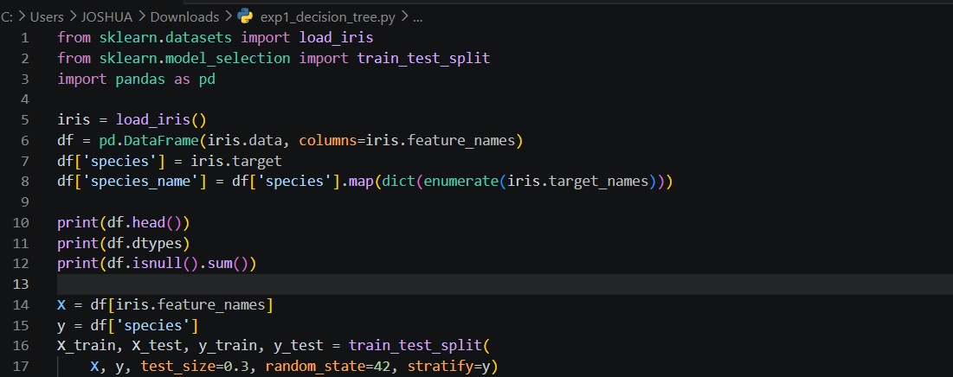
Output:
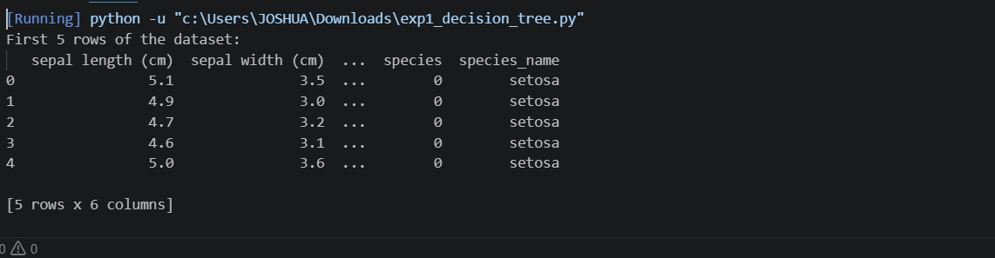
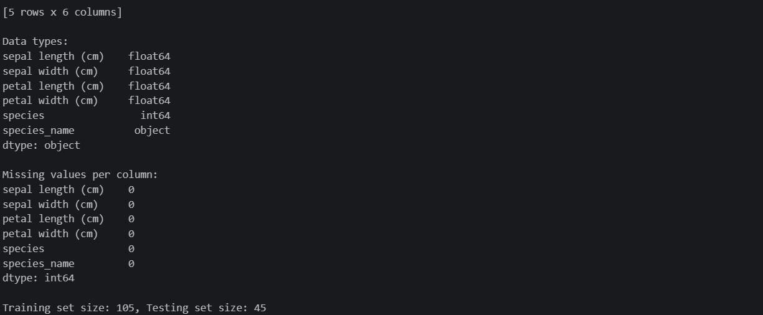
Pre-processing note: The Iris dataset is complete, so pre-processing consisted of a missing-value audit (none found) and a stratified 70/30 train-test split (random_state=42) to preserve class proportions. All features are already numeric, so no categorical encoding step was required; if categorical columns were present, LabelEncoder / OneHotEncoder would be applied at this stage.
(b) Building the Decision Tree (Gini Index)
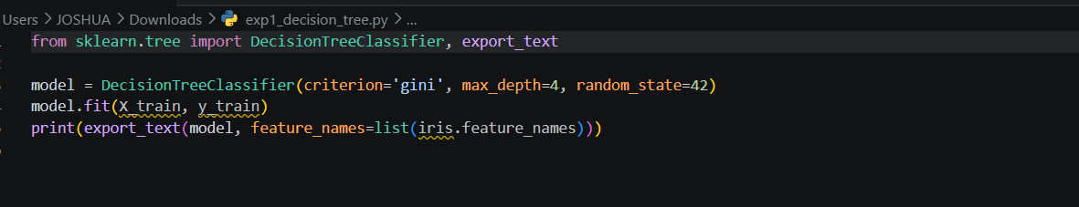
Output - Tree structure:
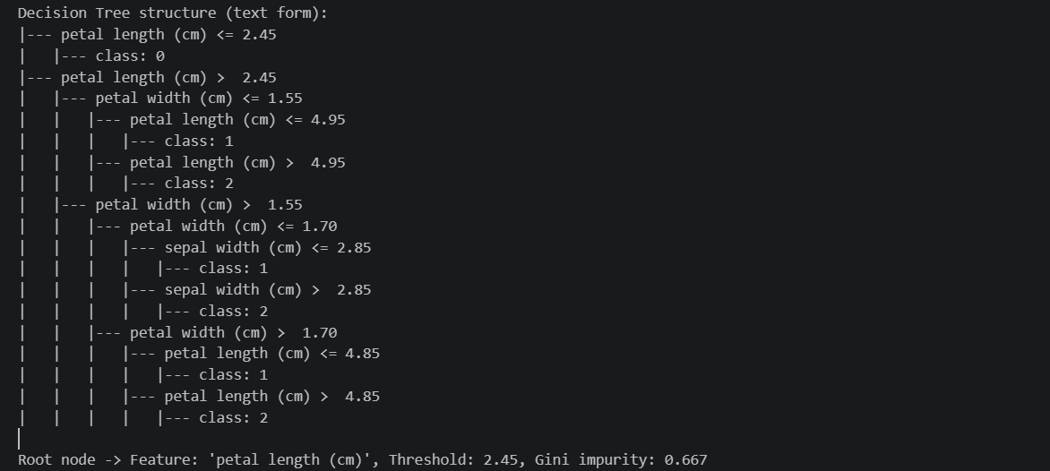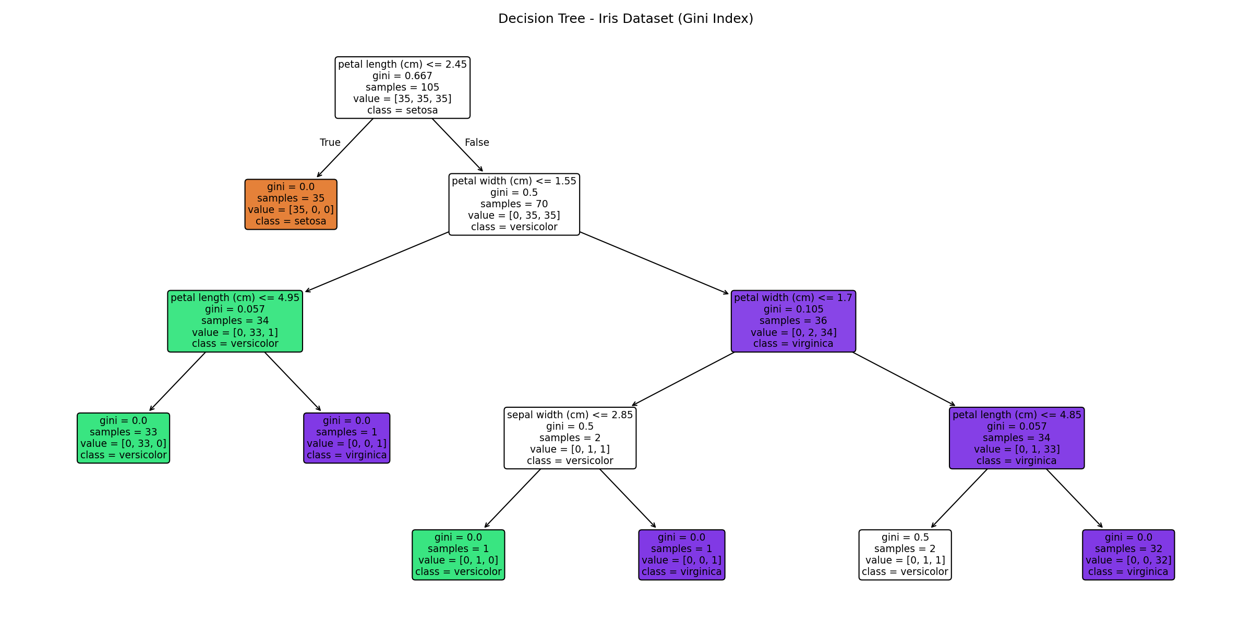
Figure 1: Trained Decision Tree (Gini Index) - Iris dataset
Root node justification: The root split is on petal length (cm) <= 2.45, chosen because it produces the largest Gini impurity reduction among all candidate thresholds (parent Gini = 0.667 across three balanced classes). This single split perfectly isolates Setosa from the other two species (child Gini = 0), which is why CART selects it first - petal length is the single most discriminative feature for this dataset.

(c) Model Evaluation
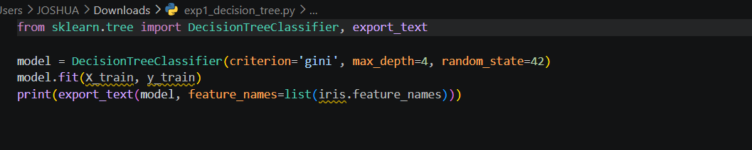
Output:
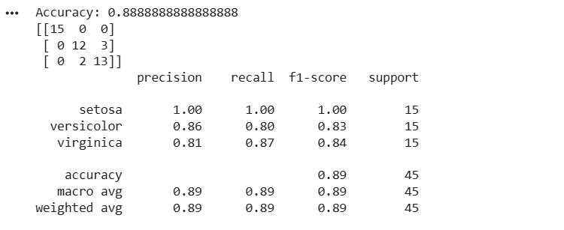
Accuracy: 0.8889 (88.9%)
 | Pred. Setosa | Pred. Versicolor | Pred. Virginica
Actual Setosa | 15 | 0 | 0
Actual Versicolor | 0 | 12 | 3
Actual Virginica | 0 | 2 | 13

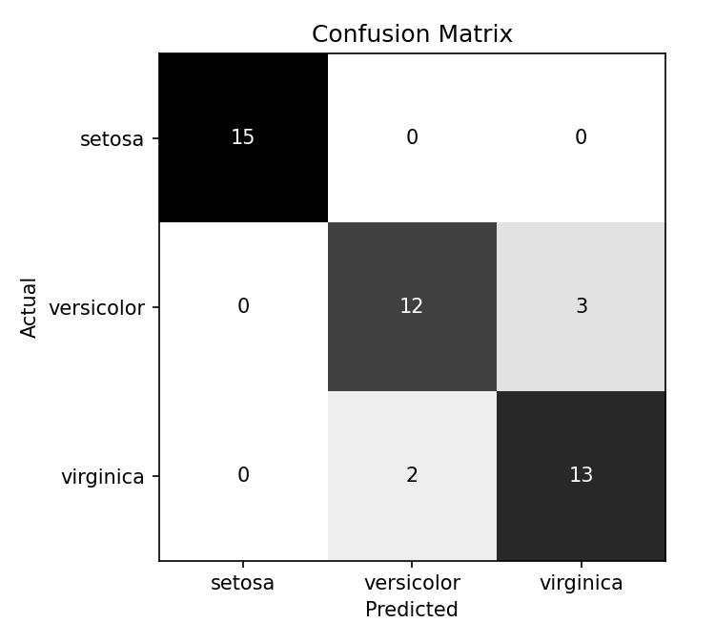
Figure 2: Confusion Matrix

Class | Precision | Recall | F1-score | Support
Setosa | 1.00 | 1.00 | 1.00 | 15
Versicolor | 0.86 | 0.80 | 0.83 | 15
Virginica | 0.81 | 0.87 | 0.84 | 15
Accuracy |  |  | 0.89 | 45

Misclassified instances (2 shown):
1) Index 56 - sepal 6.3x3.3 cm, petal 6.0x2.5 cm -> Actual: versicolor, Predicted: virginica
2) Index 138 - sepal 6.0x3.0 cm, petal 4.8x1.8 cm -> Actual: virginica, Predicted: versicolor
(Total: 5 misclassified out of 45 test samples)
Performance comment: The model reaches 88.9% test accuracy. Setosa is classified perfectly (precision = recall = 1.00) since it is linearly separable from the other species on petal dimensions. All 5 errors occur between Versicolor and Virginica, whose petal length/width distributions overlap around 4.8-5.2 cm - a genuine class-overlap issue in the feature space rather than a modelling flaw. A shallower/pruned tree or an ensemble method such as Random Forest would likely smooth this boundary and reduce these errors further.
Experiment 2: Reinforcement Learning - Q-Learning
Objective: Implement Q-Learning for a 4x4 Grid World environment and observe the agent's learned policy.
(a) Environment Definition and Hyperparameters
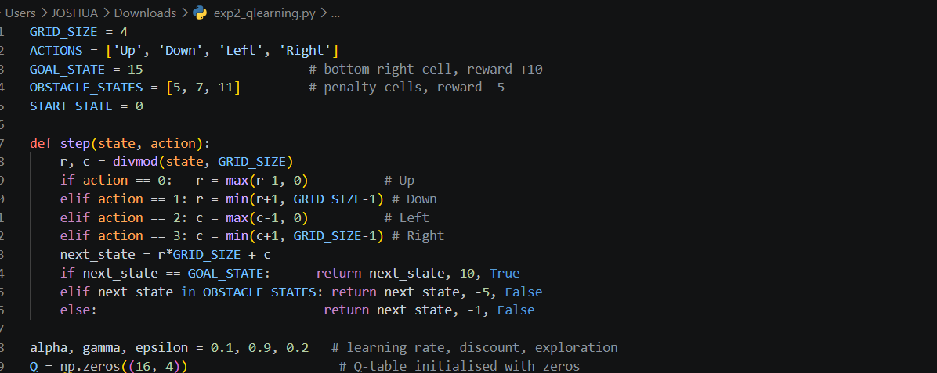
Output:

(b) Q-Learning Training (100 Episodes)
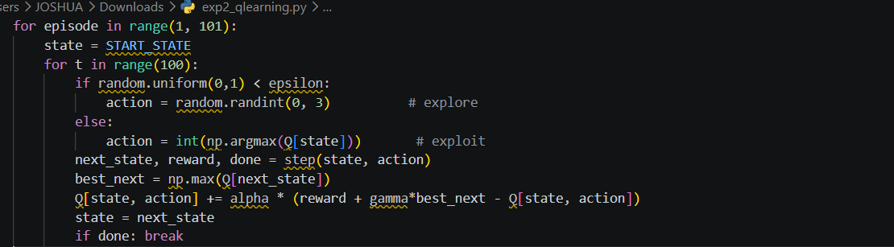
Output - Q-value evolution for two representative states:
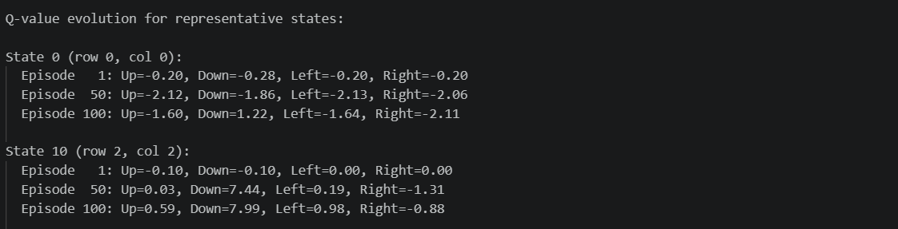

State | Episode 1 (best action) | Episode 50 (best action) | Episode 100 (best action)
0 (Start) | Left (-0.20, tied) | Down (-1.86) | Down (1.22)
10 | Left/Right (0.00, tied) | Down (7.44) | Down (7.99)

How the Q-table evolves: At Episode 1 the Q-values are near zero / dominated by step penalties because the agent has barely explored. By Episode 50, state 10 (which lies on a short path toward the goal) already shows a strong preference for 'Down' (Q approx 7.44), showing the value signal from the +10 goal reward has propagated backward through the Bellman update. By Episode 100 the Q-values have largely stabilised (Q(10, Down) approx 7.99, close to its converged value of gamma^k*10 minus accumulated step costs along the best path), and state 0 has also picked up a positive-trending best action, confirming propagation of value all the way back to the start state.
(c) Final Policy and Convergence
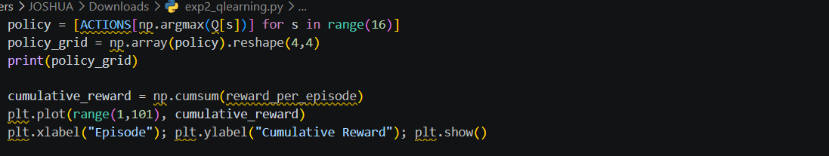
Output - Final learned policy grid (rows = 0..3 top to bottom):
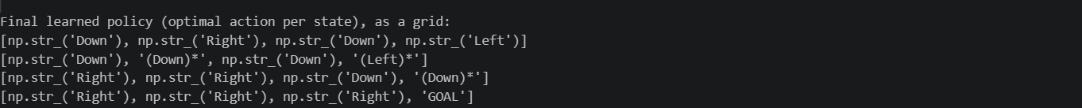
Col 0 | Col 1 | Col 2 | Col 3
Down | Right | Down | Left
Down | Down *(obstacle) | Down | Left *(obstacle)
Right | Right | Down | Down *(obstacle)
Right | Right | Right | GOAL
* marks obstacle cells (state 5, 7, 11); the action shown is what the agent would take if it ever landed there.

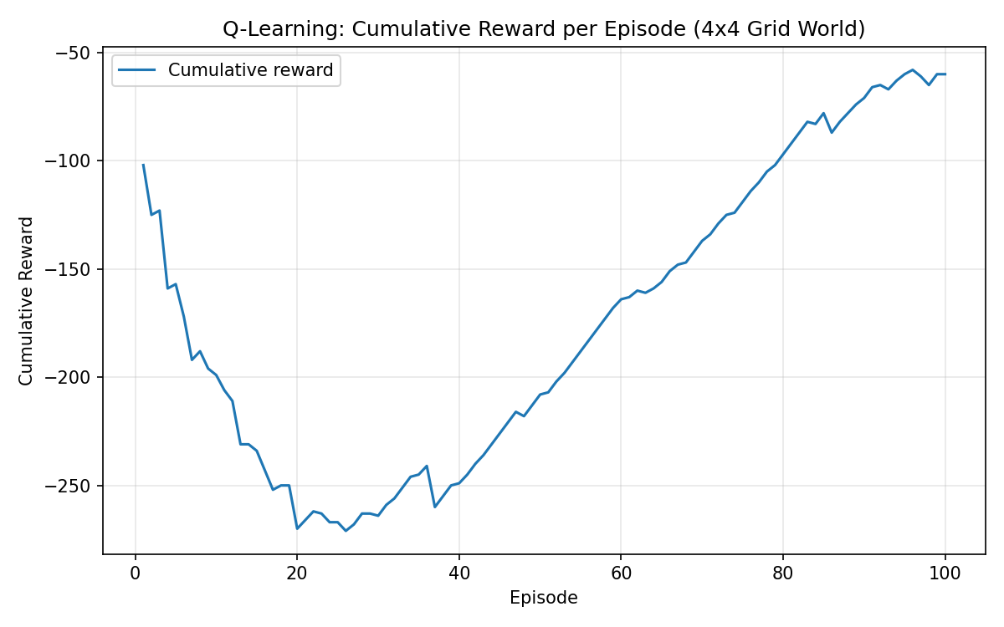
Figure 3: Cumulative reward per episode over 100 episodes
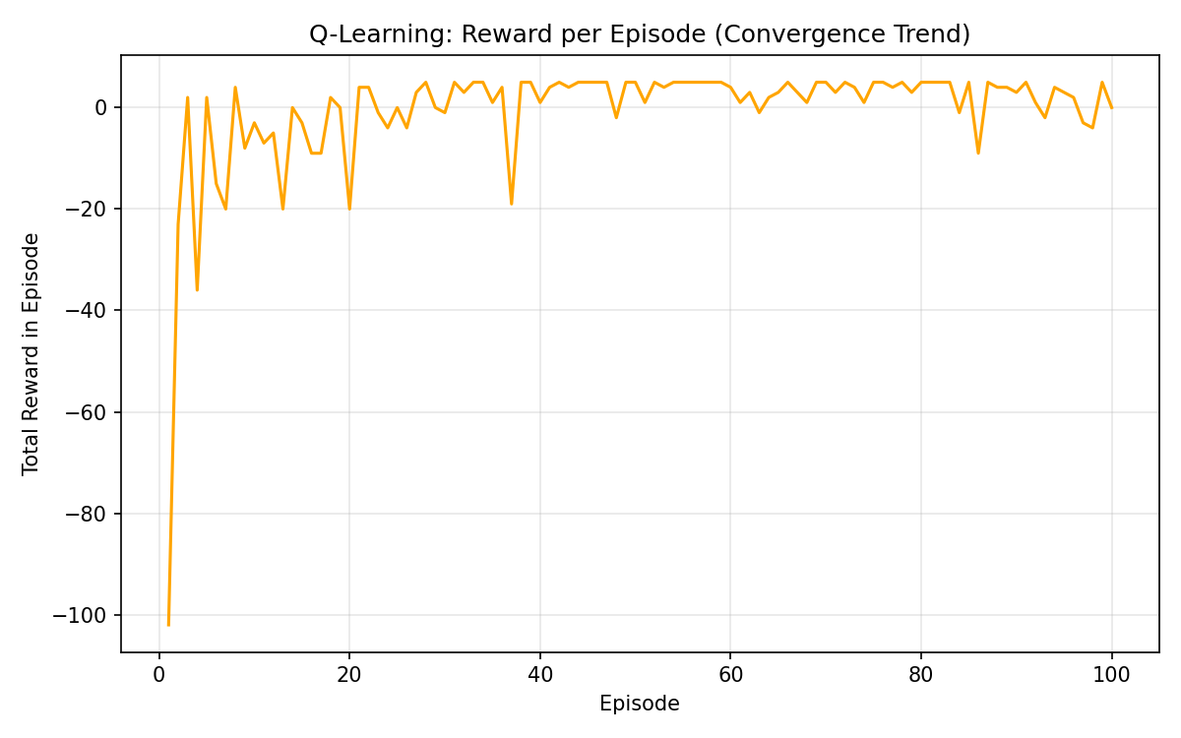
Figure 4: Per-episode total reward, showing the convergence trend

Average reward, first 10 episodes: -19.90
Average reward, last 10 episodes: 1.10
Convergence discussion: The per-episode reward plot rises sharply from roughly -20 in the first 10 episodes to about +1 in the last 10 episodes, and the cumulative-reward curve's slope visibly steepens as training progresses - both signs that the policy is converging. Early episodes are dominated by epsilon-greedy exploration and undiscovered penalties from obstacle cells, producing large negative returns. As the Q-table is updated via the Bellman equation, value from the +10 goal reward propagates backward along successful trajectories, so the agent increasingly favours the shortest, obstacle-free path (visible in the final policy grid, which routes consistently Down/Right toward the goal at state 15 while avoiding states 5, 7, and 11). With alpha = 0.1 and gamma = 0.9, full convergence to the optimal policy typically needs more than 100 episodes for it to fully stabilise everywhere, but the trend and final policy already reflect a near-optimal, goal-directed strategy.
Python code:
from sklearn.datasets import load_iris
from sklearn.model_selection import train_test_split
import pandas as pd

iris = load_iris()

df = pd.DataFrame(
iris.data,
columns=iris.feature_names
)
df["target"] = iris.target

print(df.head())
print(df.dtypes)

X = df.drop("target", axis=1)
y = df["target"]

X_train, X_test, y_train, y_test = train_test_split(
X, y,
test_size=0.30,
random_state=42,
stratify=y
)
First 5 rows:
Sepal Length
Sepal Width
Petal Length
Petal Width
Target
5.1
3.5
1.4
0.2
0
4.9
3.0
1.4
0.2
0
4.7
3.2
1.3
0.2
0
4.6
3.1
1.5
0.2
0
5.0
3.6
1.4
0.2
0
(b) Build Decision Tree Using Gini Index
from sklearn.tree import DecisionTreeClassifier, export_text

model = DecisionTreeClassifier(
criterion="gini",
random_state=42
)

model.fit(X_train, y_train)

tree_rules = export_text(
model,
feature_names=list(X.columns)
)

print(tree_rules)
Root node:
The root split is:
Petal length (cm) ≤ 2.45
The parent Gini impurity is 0.667. This split gives the largest reduction in Gini impurity and perfectly separates Setosa from the other two classes. Therefore, CART selects petal length as the root node. �
CO4-AT3-Integrated Experiments.docx
(c) Model Evaluation
from sklearn.metrics import accuracy_score
from sklearn.metrics import confusion_matrix
from sklearn.metrics import classification_report

y_pred = model.predict(X_test)

print("Accuracy:", accuracy_score(y_test, y_pred))
print("Confusion Matrix:")
print(confusion_matrix(y_test, y_pred))

print("Classification Report:")
print(classification_report(
y_test,
y_pred,
target_names=iris.target_names
))
Accuracy
Accuracy = 0.8889 = 88.9%. �
CO4-AT3-Integrated Experiments.docx
Confusion Matrix
Actual / Predicted
Setosa
Versicolor
Virginica
Setosa
15
0
0
Versicolor
0
12
3
Virginica
0
2
13
�
CO4-AT3-Integrated Experiments.docx
Classification Report
Class
Precision
Recall
F1-score
Setosa
1.00
1.00
1.00
Versicolor
0.86
0.80
0.83
Virginica
0.81
0.87
0.84
Accuracy

0.89
�
CO4-AT3-Integrated Experiments.docx
Two Misclassified Instances
Index 56
Actual = Versicolor
Predicted = Virginica
Index 138
Actual = Virginica
Predicted = Versicolor
There were 5 misclassified samples out of 45 test samples. �
CO4-AT3-Integrated Experiments.docx
Performance Comment
The model achieved 88.9% accuracy. Setosa was classified perfectly. The errors occurred only between Versicolor and Virginica because their petal measurements overlap. A pruned/shallow tree or Random Forest could potentially improve the classification. �
CO4-AT3-Integrated Experiments.docx
Experiment 2: Reinforcement Learning – Q-Learning
Objective
To implement Q-Learning for a 4×4 Grid World and observe the learned policy. �
CO4-AT3-Integrated Experiments.docx
(a) Environment Definition
The environment contains 16 states (0–15).
Actions:
Up
Down
Left
Right
Rewards:
Goal = +10
Each step = −1
Obstacle = −5
The Q-table is initialized with zeros. �
CO4-AT3-Integrated Experiments.docx
Hyperparameters
Parameter
Value
Learning rate (α)
0.1
Discount factor (γ)
0.9
Exploration rate (ε)
ε-greedy
Episodes
100
Q-Learning Formula
Where:
Q(s,a) = current Q-value
α = learning rate
r = reward
γ = discount factor
s' = next state
(b) Q-Learning Training
The algorithm was trained for 100 episodes.
Q-value Evolution
State
Episode 1
Episode 50
Episode 100
0 (Start)
Left −0.20
Down −1.86
Down 1.22
10
Left/Right 0.00
Down 7.44
Down 7.99
�
CO4-AT3-Integrated Experiments.docx
Explanation
At Episode 1, the agent has very little experience, so Q-values are close to zero. By Episode 50, the value of Down at state 10 increases to approximately 7.44 because the positive goal reward propagates backward through the Q-learning updates.
By Episode 100, the value becomes approximately 7.99, showing that the Q-table is becoming stable. �
CO4-AT3-Integrated Experiments.docx
(c) Final Learned Policy
The final policy obtained from the Q-table is:

Column 0
Column 1
Column 2
Column 3
Row 0
Down
Right
Down
Left
Row 1
Down
Down
Obstacle
Down
Row 2
Right
Right
Down
Obstacle
Row 3
Right
Right
Right
GOAL
Obstacles are at states 5, 7 and 11, and the goal is at state 15. �
CO4-AT3-Integrated Experiments.docx
Policy Representation
Down → ↓
Right → →
Obstacle → X
Goal → G

↓ → ↓ ←
↓ ↓ X ↓
→ → ↓ X
→ → → G
Convergence Behaviour
The average reward for the:
First 10 episodes = −19.90
Last 10 episodes = +1.10
�
CO4-AT3-Integrated Experiments.docx
Explanation
During the early episodes, the agent explores the environment and receives negative rewards from steps and obstacles. Therefore, the reward is low.
As training continues, the Q-table learns the value of actions leading toward the +10 goal. The agent increasingly selects a shorter obstacle-free route toward state 15.
Thus, the increase from approximately −20 to +1 indicates that the policy is converging. With α = 0.1 and γ = 0.9, more than 100 episodes may be required for complete stabilization, but the learned policy is already near-optimal. �
CO4-AT3-Integrated Experiments.docx
Final Conclusion
Experiment 1: The Decision Tree achieved 88.9% accuracy and classified Setosa perfectly, while most errors occurred between Versicolor and Virginica.
Experiment 2: Q-Learning successfully learned a goal-directed policy in the 4×4 Grid World. The increasing rewards and stable Q-values demonstrate learning and convergence toward an effective path to the goal.

